

**Universidad Israel**

**DEPARTAMENTO:** Ciencias de la Ingeniería **PROFESOR:** Mg. Tannia Mayorga.

**CARRERA:** Sistemas de Información **ESTUDIANTE:** Marco Ayala

**CURSO:** Séptimo **PARALELO:** “A“ **DESCRIPCIÓN:** Lab 3.7.10-S4

**ASIGNATURA:** Redes de Datos 1

**TEMA: Laboratorio 3.7.10**

**DESARROLLO:**

Paso 1,

1. hacer el ipconfig /all en el cmd

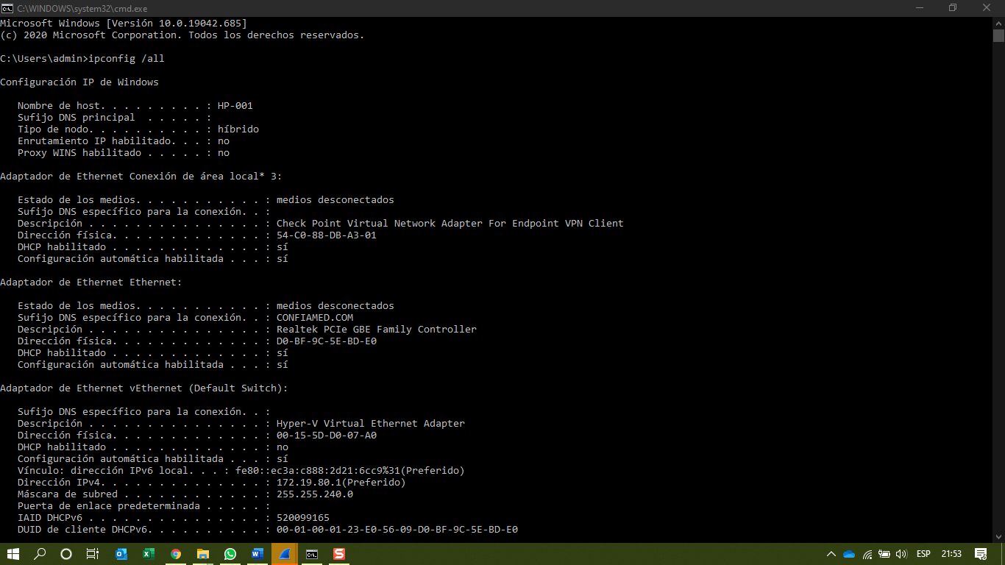

1. Ask a team member or team members for their PC IP address and provide your PC IP address to them. Do not provide them with your MAC address at this time.

*En este caso como trabajo con una pc trabajaremos con la ip local*

Paso 2, Iniciamos Wiresark

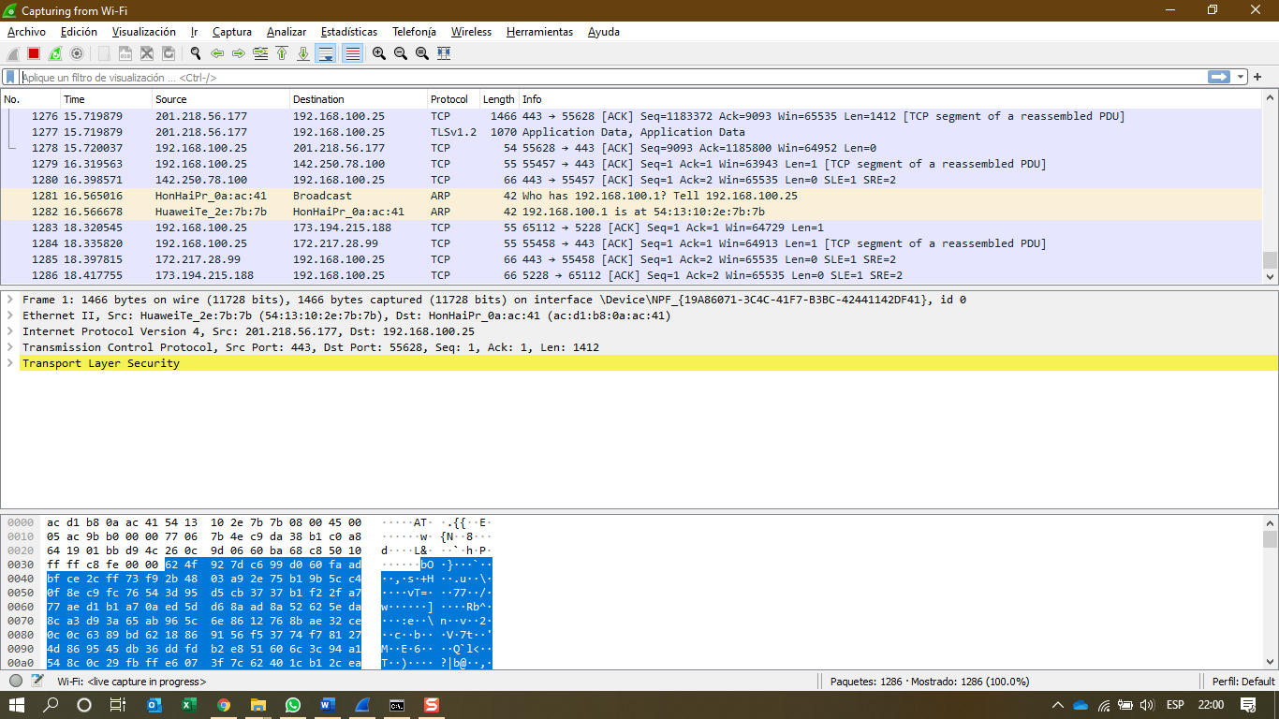

Capturando icmp

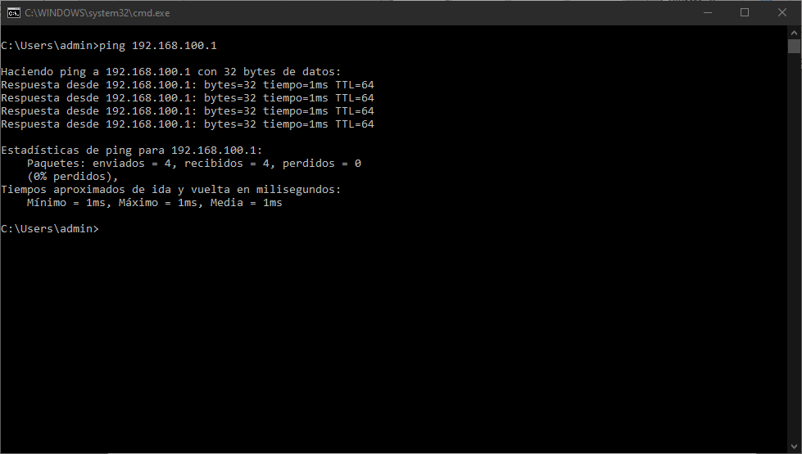

Examinamos los datos ICMP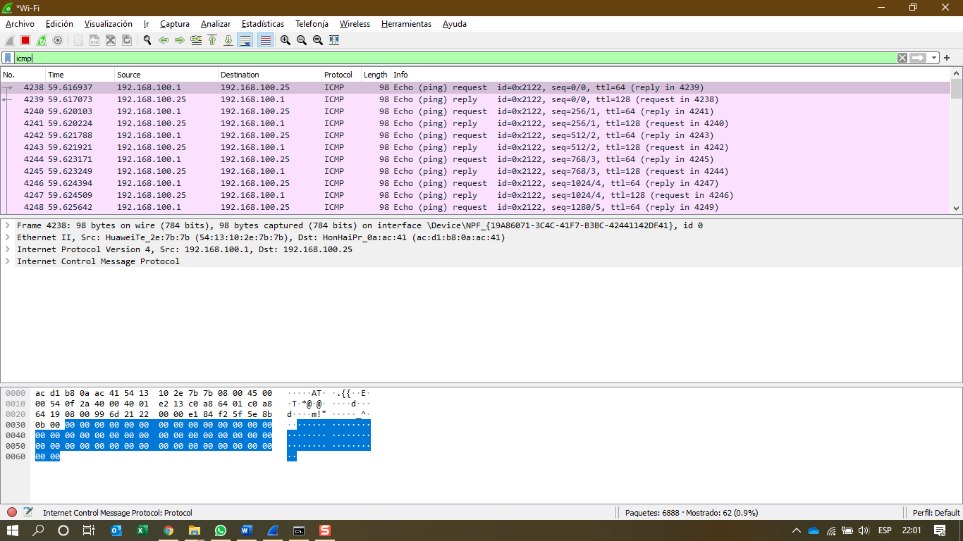

Ahora revisamos los detalles

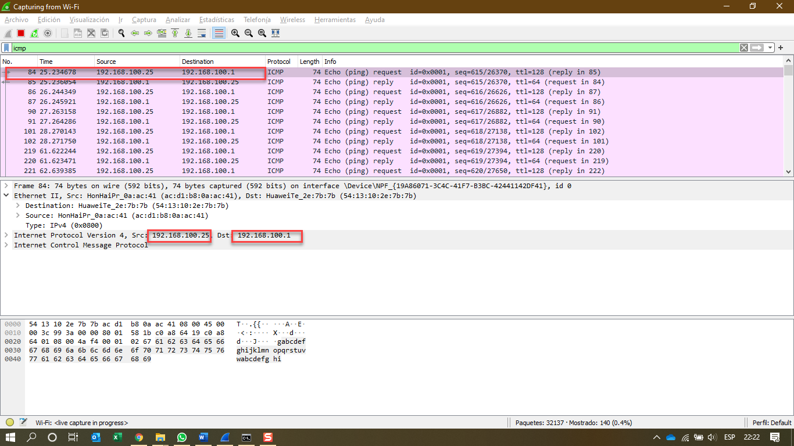

Comprobamos la dirección mac del destino

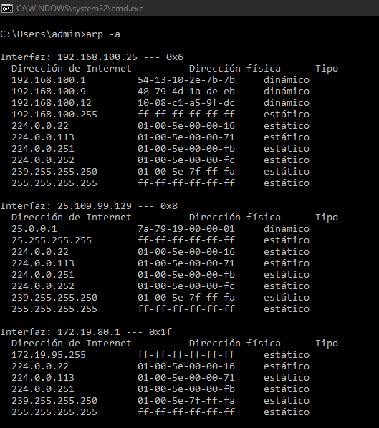

Does the source MAC address match your PC interface?

**Yes**

Type your answers here. Does the destination MAC address in Wireshark match your team member MAC address?

**Yes**

Type your answers here. How is the MAC address of the pinged PC obtained by your PC?

**Yes, Mediante arp -a**

Paso 2

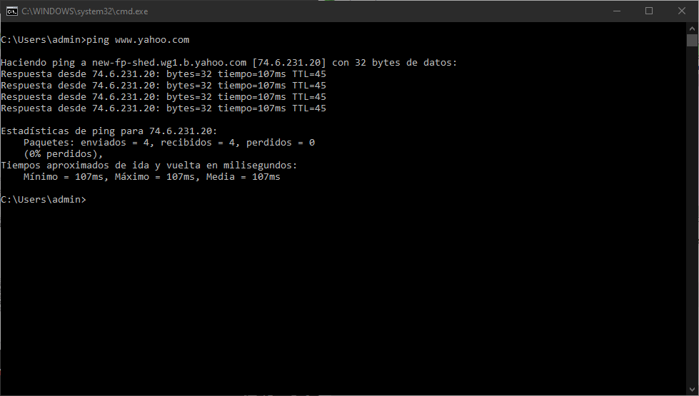

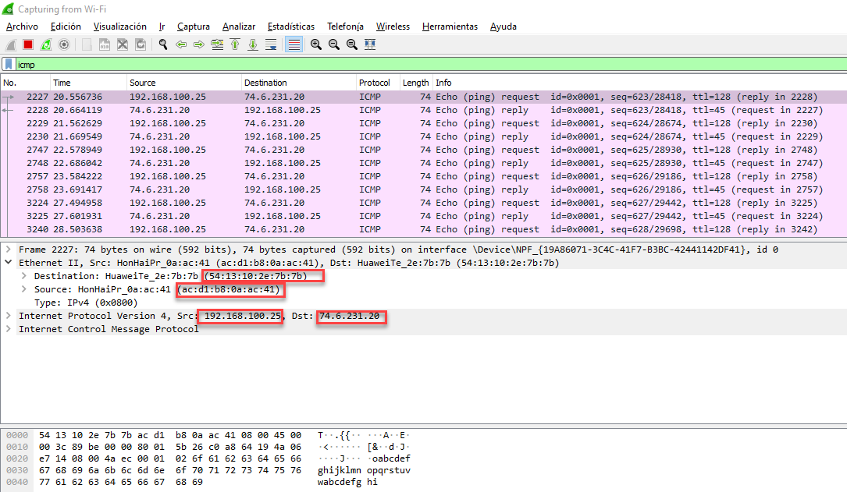

What is significant about this information?

**La dirección física es la misma por que es la interface del router para los sitio visitados**

Type your answers here. How does this information differ from the local ping information you received in Part 1?

**La Puerta de enlae siempre será la misma**

**Reflection Question**

Why does Wireshark show the actual MAC address of the local hosts, but not the actual MAC address for the remote hosts?